Test Report

for

Fitness Assistant

Prepared by Hamsa Bharathi (11), Vishtasp Meherhomji (13), Anshul Jain (16), Daksh Taneja (33)

IT-A1

13th September, 2017

**Table of Contents**

Table of Contents 2

1. Introduction 3

1.1 Purpose 3

1.2 Document Conventions 3

1.3 Intended Audience and Reading Suggestions 4

1.4 Definition, Acronyms and Abbreviations……………………………...……………….….4

1.5 Product Scope 4

1.6 References 4

2. Overall Description 5

2.1 Product Perspective 5

2.2 Product Functions 5

2.3 User Classes and Characteristics 6

2.4 Operating Environment 6

2.5 Design and Implementation Constraints 7

2.6 User Documentation 7

2.7 Assumptions and Dependencies 7

3. External Interface Requirements 8

3.1 User Interfaces 8

3.2 Hardware Interfaces 9

3.3 Software Interfaces 9

3.4 Communications Interfaces 10

4. System Features 11

4.1 Login 11

4.2 Register 11

4.3 Choose Equipment 11

4.4 Choose Trainer 12

4.5 Fees Calculation 12

4.6 Calculate BMI 13

4.7 View Members to train 13

4.8 View Details 13

4.9 Buy Equipment 14

4.10 Diet Plans 14

5. Other Nonfunctional Requirements 15

5.1 Performance Requirements 15

5.2 Safety Requirements 15

5.3 Security Requirements 15

5.4 Software Quality Attributes 15

5.5 Business Rules 16

6. Other Requirements 17

Appendix A: Analysis Models 17

6.1 Use Case Diagram………………………………………………………………………..17

6.2 Activity Diagram………………………………………………………………………...18

6.3 Class Diagram……………………………………………………………………………19

6.4 Sequence Diagram……………………………………………………………………….20

6.5 State Machine Diagram………………………………………………………………….21

1. Introduction

The introduction provides an overview of the entire SRS with purpose, scope, definitions, acronyms, features, abbreviations, references and overview of it. The aim of this document is to gather, analyze and give an in-depth insight of the **Fitness Assistant** by defining the problem statement in detail. It also concentrates on the capabilities required by stakeholders and their needs while defining high-level product features. The detailed requirements of the Fitness Portal are provided in this document.

## Purpose

The purpose of the document is to collect and analyze all assorted ideas that have come up to define the system and its requirements with respect to consumers. Also, we shall predict and sort out how we hope this product will be used in order to gain a better understanding of the project, outline concepts that may be developed later, and document ideas that are being considered, but may be discarded as the product develops. It also defines how our client, team and audience see the product and its functionality.

In short, this document provides a detailed overview of our software product, its parameters and goals. This document describes the project's target audience and its user interface, hardware and software requirements.

This project aims at creating a software which would facilitate the members to undertake their regular fitness activities. The product of our project is hence an online portal which helps in facilitating the daily activities with respect to maintaining fitness.

## Document Conventions

* Font style – Times New Roman
* Font color – Black
* Line spacing – Single (1.0)
* Font size:

1) For main heading - 18

1. For sub headings - 14
2. For all paragraphs- 12

* All-important words/keywords are written in **bold**

## Intended Audience and Reading Suggestions

This SRS is intended to be read by the software designers, developers, testers as well as the customer and any stake-holder. It is meant for them to obtain a clear understanding of the requirements, necessities as well as programming essentialities.

The SRS is organized such that it can provide a clear overview of the portal for its readers.

To understand it best, the SRS should be read in order, from start to finish.

## Definitions, Acronyms, and Abbreviations

|  |  |
| --- | --- |
| FAQ | Frequently Asked Questions |
| BMI | Body Mass Index |
| JDK | Java Development Kit |
| SQL | Structured Query Language |
| LAN | Local Area Network |

**1.5 Scope**

The online portal helps members schedule their daily activities for maintaining their health. It also offers managers better access to the functioning of the portal.

It will simplify the task and reduce the paper work. During implementation every user will be given appropriate fitness guidelines to suit their specific needs. These will be provided on a timely basis and according to the user’s need.

The portal is very user-friendly and functions of the online portal can be easily accessed by all the members, fitness experts, and managers.

## References

The references are:

https://material.io/guidelines (for designing the GUI)

https://w3schools.com

# Overall Description

## Product Perspective

The criteria of health and fitness all over the world is expanding day by day. Everybody is being more conscious towards their health and wants to be fit throughout their lives. It is a big challenge to the whole human fraternity to maintain fitness together with the technological improvement in the modern world.

This product, the online fitness assistant, is aimed at improving the overall system of availing better fitness guidelines. It provides an easy mechanism to maintain the members, fitness experts and equipment purchase.

## Product Functions

The Fitness Assistant will provide the following functions to different types of users:

* Registration for a person who wants to become a member of the portal.
* Provision for the manager of the portal to register a fitness expert.
* The managers will be able to update the portal.
* The manager will be able to keep a record of the information of each member, his/her diet and fitness guidelines
* Members can update their current fitness status.
* Email reminders are sent to members who visit the portal infrequently.
* Important fitness updates are also sent by email.
* Provide a diet chart as prescribed by fitness expert for the appropriate trainee according to fitness regime.
* Integrate Google Fit data for the members
* The portal will be integrated with a calendar to keep track of diet and frequency of visit easily.
* The portal will provide a help feature, depending on the type of user using it that will answer FAQs pertaining to its usage.
* There will also be a facility to register members using their mobile numbers.

## User Classes and Characteristics

* **Portal Managers:**
  + They can access the system and have maximum permissions on the portal.
  + Can register a new fitness expert and can manage them and the members.
  + Can add/edit the portal facilities.
  + Can see all the people registered in the portal.
  + Can provide members their contact details if members specially request for it.
* **Member:**
  + Keeps a track of his/her identity and health details.
  + Can register with one or multiple experts.
  + Can edit their personal details.
  + Can view his/her approved diet.
  + Can view details about their use of the portal.
* **Fitness Expert:**
  + Can view information of members registered with them.
  + Suggest diet and weight plan for the members.
  + Update his/her personal information and experience.
  + Restrict number of members.
  + Customize consultation fees.

## Operating Environment

Any device, which supports Chrome, Firefox or IE 9.0 and above, will run this portal. The portal also has a database to store required information, so the system must also have adequate memory for the same.

## Design and Implementation Constraints

The basic hardware requirements shall be as follows:

* 700MHz Processor
* 256MB RAM

The language used throughout this project shall be English.

## User Documentation

At the time of deployment, a User Manual will be provided with it. Also, the portal will have a ‘Help’ included in it.

## Assumptions and Dependencies

The product needs:

* A compatible browser to view the portal
* A platform for the browser to run and display the color specifications properly
* SQL support

The success of this system will depend on:

* Existence of adequate memory
* The user should be willing to adopt
* Are users comfortable with computers and have enough knowledge to work with the product?

# External Interface Requirements

## User Interfaces

The user interfaces vary depending upon the type of user. For example, the interface for a member will allow the user to navigate between the guidelines page, the equipment purchase page, calendar, etc. Another essential component of the user interface for a member would be the calculation and display of the fees that the member would require to pay.

The members can view or update their personal details, and also view certain details of the fitness experts. Members can also purchase equipment, calculate their fees, etc. Experts can view certain details of members, see their consultation fees, view the members registered with them, etc. Managers have access to all.

A sample GUI for the login page:

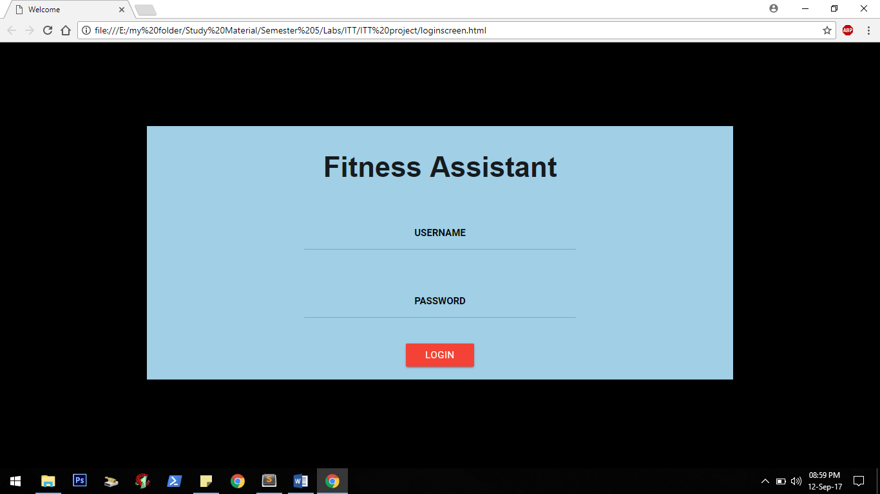

And one for the BMI calculator:

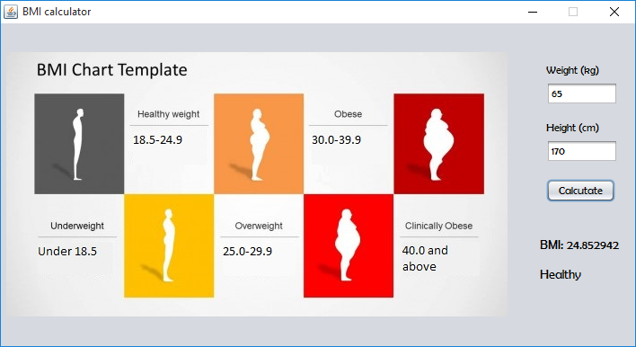

## Hardware Interfaces

The portal can run on any device which can support browsers as Chrome, Firefox or IE 9.0 and above. The portal would require any device which is running it to be able to support the user interface with speed and efficiency.

The portal would keep updating the database as and when a user makes an entry, or a modification. The device would need to keep track of any such changes and ensure their security.

## Software Interfaces

The two main software components include the user interface, and the database. The user interface is developed using HTML, CSS, JavaScript, etc. and the database is developed and managed via the use of PHP.

The databases store various information such as member/fitness expert details, members’ fitness, product information, etc. All of this information is made available to users, depending on the type of user. For example, a member cannot access the information about the consultation fees being paid to a certain expert. This ensures the security of the data.

Any information entered by any user is appropriately stored and maintained in the database. The user interface will constantly provide all the required support for the specific user.

## Communications Interfaces

The portal is used online. Any user can access the portal on any device which can support it.

The devices must be connected to the internet (World Wide Web). The database is stored on a PHP server, which can be updated by any device running the portal. The portal ensures adequate support for all the data exchange amongst the various devices and the central server.

# System Features

## Login

4.1.1 Description and Priority

Logging-in is one of the most important and basic features of the portal. It is essential as it allows the system to decide what, and to what extent, access is to be given to a particular user. Login also enables to update the visit frequency of each user.

4.1.2 Stimulus/Response Sequences

The user must choose the kind of user (member/fitness expert/manager) that he/she is, and accordingly proceed to provide the username and password in order to login.

4.1.3 Functional Requirements

REQ-1: An interface to prompt, accept and interpret user input must be present.

REQ-2: Access to database should be available to authenticate the user.

REQ-3: Display of error message must be shown if username/password is incorrect.

REQ-4: Access must be granted if username and password are valid.

## Register

4.2.1 Description and Priority

This feature is of importance to any person who wishes to become a member of the portal. Registering is the first step in becoming a member.

4.2.2 Stimulus/Response Sequences

The user must enter all the details asked for (truthfully to the best of their knowledge). The portal would then store these details in the database and register the user as a member of the portal.

4.2.3 Functional Requirements

REQ-1: An interface to prompt, accept and interpret user input must be present.

REQ-2: Access to database should be available to store the information of the member

REQ-3: Show error if all details are not filled

## Update Fitness Details

4.3.1 Description and Priority

This feature provides members the ability to select all the equipment that they wish to use. The equipment are grouped into packages, one of which can be chosen by a member. This feature is of high importance, since this allows the member to access the facilities of the gym, as well as helps in calculating the member’s fees.

4.3.2 Stimulus/Response Sequences

Members are prompted to select an equipment package at the time they register. They are given the details of the package, as well its fees. The members are also allowed to change their preferences later.

4.3.3 Functional Requirements

REQ-1: An interface to prompt, accept and interpret user input must be present.

REQ-2: Access to database should be available to store the selection of the member.

REQ-3: Should not allow members to choose more than one package.

REQ-4: Should allow a member to update their preferences at a later stage too

## Choose trainer

4.4.1 Description and Priority

Members are allowed to choose the trainer they wish to train under. A member may choose only one trainer, and cannot choose a trainer who is training 10 members already. This is important, since every member must have a trainer to ensure efficient and safe use of equipment.

4.4.2 Stimulus/Response Sequences

Members are prompted to select a trainer at the time they register. They are given details of all the trainers, including the number of members the trainers currently train. The members are also allowed to change their preferences later.

4.4.3 Functional Requirements

REQ-1: An interface to prompt, accept and interpret user input must be present

REQ-2: Access to database should be available to store the selection of the member

REQ-3: Should not allow a member to choose more than one trainer, or one who is training 10 members.

REQ-4: Should allow members to update their preferences at a later stage too.

## Fees calculation

4.5.1 Description and Priority

The fees that need to be paid by a certain member are calculated based on the equipment package they choose, as well as the duration for which they choose to be a member. This is very important, as the gym requires its members to pay their fees for functioning of the gym.

4.5.2 Stimulus/Response Sequences

Members are informed about the fees they are expected to pay for the equipment they chose to use. They can see this information anytime they wish.

4.5.3 Functional Requirements

REQ-1: A method to compute the fees based on the members’ preferences.

REQ-2: Access to database should be available to retrieve the members’ preferences

REQ-3: An interface to display the fees should be made available

## Calculate BMI

4.6.1 Description and Priority

Maintaining the correct BMI is important. The members should be able to calculate their BMI and see it. It is fairly importance, as it can help members set BMI targets and train in the gym accordingly, as well as help trainers suggest diet plans.

4.6.2 Stimulus/Response Sequences

The members simply need to supply their weight and height in the BMI calculator. The calculator shows the BMI value, as well as displays what category that value comes under.

4.6.3 Functional Requirements

REQ-1: An interface to read user input and display output

REQ-2: An algorithm to calculate the BMI and display the category

## View members to train

4.7.1 Description and Priority

This feature is for trainers to use. It enables them to see which all members are training under them.

4.7.2 Stimulus/Response Sequences

The trainers are given information about the members training under them. They can accordingly plan the training required for each member.

4.7.3 Functional Requirements

REQ-1: An interface to show member information must be present

REQ-2: Access to database should be available to retrieve the information of the members

## View details

4.8.1 Description and Priority

This feature is for all users. Members can see their own details, as well as of their trainers. Trainers can see their own information, as well as that of the members training under them. Managers can see details of everyone.

4.8.2 Stimulus/Response Sequences

All users are allowed access to user details to varying extents. While members and trainers have limited access, managers can access all details. They merely need to ask the system to show the required details, and based on the type of user, the system will provide the details.

4.8.3 Functional Requirements

REQ-1: An interface to show user information must be present

REQ-2: Access to database should be available to retrieve the information of the users

## Buy equipment

4.9.1 Description and Priority

Members have the option of purchasing equipment. The portal provides its members the facility of purchasing certain equipment for themselves.

4.9.2 Stimulus/Response Sequences

Members must select the equipment they wish to purchase, and this information is then available for the managers to view. The manager can then arrange for the equipment to the member, and the cost for the same is added to the member’s fees.

4.9.3 Functional Requirements

REQ-1: An interface to show equipment details should be present

REQ-2: Access to database should be available to store the member’s selection.

REQ-3: The managers must be able to view the purchases requested by the members, and be able to pass these requests.

## Diet Plans

4.10.1 Description and Priority

Fitness Experts suggest appropriate diet plans for the members registered under them. This is done based on the member’s physical parameters and age. This is of high importance, since a member must be aware of the right diet for being fit.

4.10.2 Stimulus/Response Sequences

The fitness expert can view the member’s details, and accordingly adjust the diet plan of the member, as per their requirements. The members can view the diet plan suggested by the fitness expert.

4.10.3 Functional Requirements

REQ-1: An interface to view details, update and view diet plans

REQ-2: Access to database should be available to store the suggested diet plan

REQ-3: The fitness expert should be able to suggest diet plans only for the members they train

# Other Nonfunctional Requirements

**5.1 Performance Requirements**

• No more than a 5-percent degradation in average query response is allowed while all concurrent users are using the portal.

• Processor utilization should not exceed 80 percent during all concurrent users are using the portal.

**5.2 Safety Requirements**

The design of the online portal is such that it ensures minimal loss of data and precision.

The web portal is divided into three different Modules – Manager, Member and Fitness Expert. This ensures complete atomicity and security of the data. Hence, it is completely secure and all details of the users are within private classes so that no 3rd party can access it. We also ensure that neither the administrator nor the developers will misuse the software for their own purposes.

**5.3 Security Requirements**

• Passwords will be safely stored within the database.

• There is a three level accessibility created in the portal, were data viewing, updating and editing is provided accordingly.

**5.4 Software Quality Attributes**

**Reliability:**

• The database should maintain data by implementing a primary and foreign key system so that discrepancies do not occur within the data.

**Efficiency:**

• The user interface shouldn’t unnecessarily crash while updating data etc.

**Maintainability:**

• Managers will have the ability to edit the aspects of the portal for changes. They can also handle other functions like updating equipment details, updating the calendar of events, and including health tips for the members.

**5.5 Business Rules**

The business goal for the application is to increase efficiency of the interface.

* The Manager needs to sign in to modify anything.
* The Manager does most of the updating tasks, such as updating events calendar, including health tips, adding new fitness experts etc.
* The Members and fitness experts form a very integral role in the functioning of the portal.

# Other Requirements

Appendix A: Analysis Models

Certain diagrams are essential for explaining the functioning of the software as well as the interconnection between the various components and features. The following UML diagrams attempt to serve this purpose:

1. The Use Case Diagram:

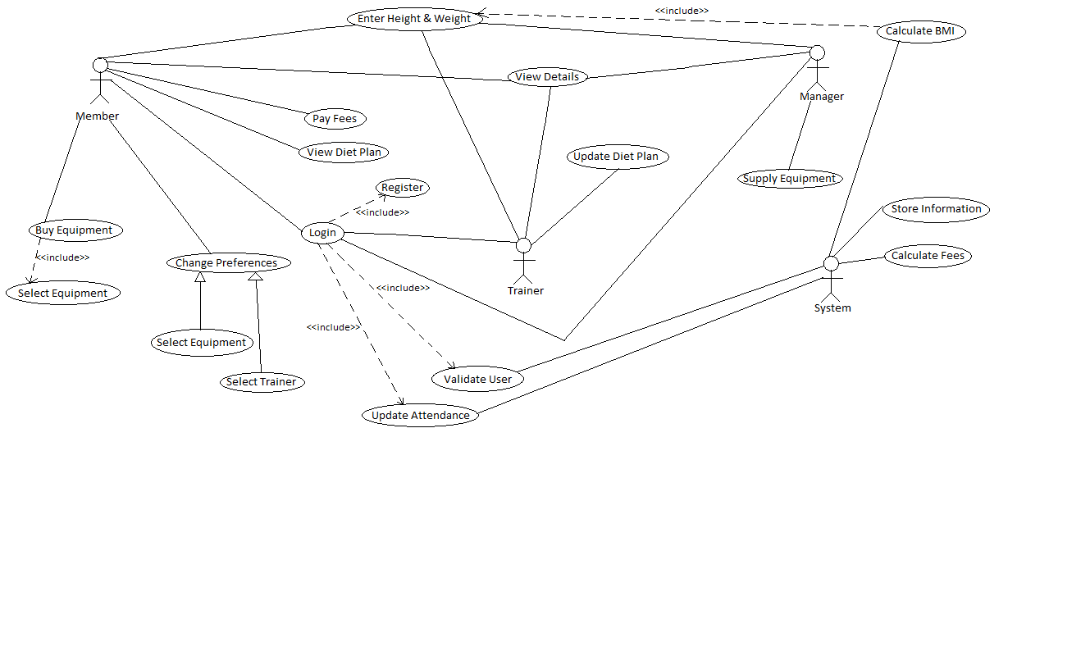

1. The Activity Diagram:



1. The Class Diagram:

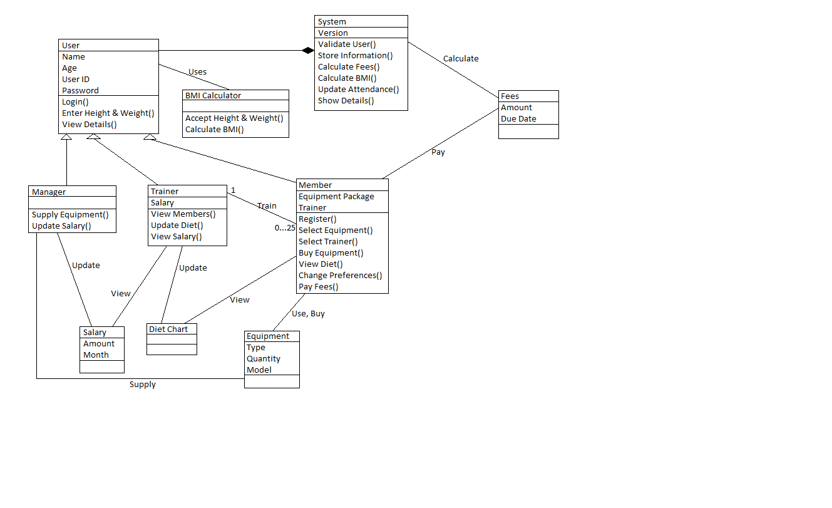

# The Sequence Diagram:

# 

1. The State Machine Diagram:

